Max Plomer

University of Connecticut

*For Dr. Pasaogullari’s Computational Fluid Dynamics Class*

December 17th, 2010

**Numerical Simulation of a Converging Diverging Nozzle: Effect of Outlet Area on Mach Number and Acceptable Back Pressures**

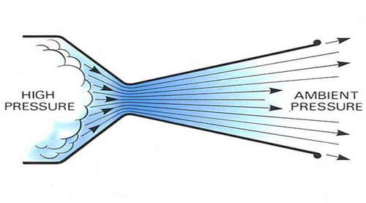

**Introduction**

Converging-diverging nozzles, also called CD nozzles, are a cylinder that is narrow in the middle. They are used to accelerate hot exhaust gases to supersonic velocities, thereby converting as much of the flow’s energy into kinetic energy. They are used in steam turbines, rocket engines, and jet engines. Given a large enough pressure drop from inlet to outlet, in the converging section of the nozzle the flow accelerates to the speed of sound, then during the diverging section the flow continues to accelerate to supersonic speeds.

During supersonic flow, as the back pressure is increased (and thus the pressure drop is decreased) a shock will form in the diverging section of the nozzle, where the flow shocks from supersonic to subsonic speeds. This is incredibly undesirable as you are not maximizing the nozzle geometry in the conversion of flow energy into kinetic energy and can damage the engine. If the back pressure is increased enough, supersonic speeds will not form in any part of the nozzle. An increase in the area of the outlet gives a higher mach number at the exit, but limits the range of back pressures in which the rocket can operate.

Since this flow will have a large Reynolds number, viscous effects will be small, therefore the flow is modeled as inviscid. This is a reasonable assumption, since for the turbulent flow, the viscous effects will stay close to the wall.

The objective of this project is to perform this nozzle investigation using a CFD software package called Fluent. For the range of nozzle outlet areas, we will find the maximum acceptable back pressures. We will also see, for a constant back pressure, how the increase in outlet area increases Mach number at flows near the wall and at the center line of the nozzle.

**Simulation Methods**

**Simulation Conditions:** This simulation will model air flowing at high speeds through a circular cross-section, custom designed converging-diverging nozzle. The air will be atmospheric at the inlet, with a pressure of 101.325 kPa and temperature of 300K. For comparing the change in outlet area, the outlet conditions will be a pressure of 3 kPa and temperature of 300K. This back pressure was used because the pressure drop created supports supersonic flow throughout the entire diverging section of the nozzle for the entire range of outlet areas.

**Fluent Physics Options:**

• Time: Solving for the steady-state solution only.

• Solver: Since we have a high‐speed compressible flow, the density‐based solver was chosen. This is the solving approach that has been traditionally used for high-speed compressible flows, it uses the continuity equation to obtain the density field.

• Space: Solving the axi‐symmetric form of the governing equations is key to a quick converging simulation because of the computational savings. Since the velocity at a certain distance through the nozzle is a function of the radial distance from the centerline, the model will be a two-dimensional slice of the flow.

• Viscous Model: The flow is modeled as Inviscid, meaning the solver will neglect the viscous terms in the equations because the area of viscous effects will stay close to the wall for turbulent/high-Reynolds-number flow.

• Using Energy Equation, because it is a compressible flow, the energy equation will be coupled to continuity and momentum equations

• Density of Air: We will use the ideal gas law to calculate the density of air from temperature and pressure.

• Pressure inlet: 101,325 Pa @ 300K, Pressure outlet: 3,000 Pa @ 300K

• Solution Methods: Second Order Upwind was used for calculations which should take longer to converge, but was not an issue because of the computational savings from the use of the axi-symmetric form of the governing equations. For the Maximum Back Pressure analysis, First Order Upwind was used to deal with the instabilities at those high back pressures, which would not allow convergence to occur with the Second Order Upwind scheme.

• Criteria for Convergence: Used a convergence Criteria of 1*10‐6 for my continuity, x-velocity, y-velocity, and energy equations, which will yield an accurate solution.

• 600 Iterations, this was determined by running the simulation.

**Nozzle Design**

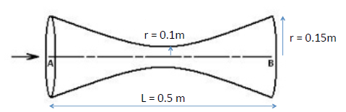

For the nozzle design I used an equation for the curvature of the wall of the form:

y= ax2 + b

With points (0, 0.1) and (0.25, 0.15), therefore the equation becomes: a = 0.8, b = 0.1

The outlet radius is increased up to r = 0.3m to see how the Mach number at the wall and axis is affected.

**Two-Dimensional Mesh**

Since axi-symmetric, only the top half was modeled. The computational space is divided by a 40x100 mesh.

The boundaries were set as follows:

Top: Wall

Bottom: Axis

Left: Pressure-inlet

Right: Pressure-outlet

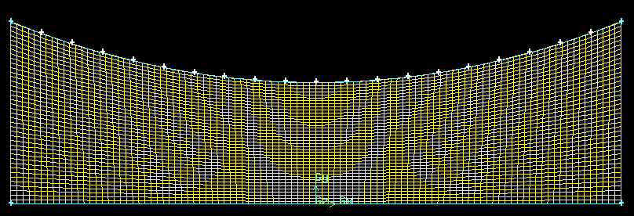

**Results and Discussion**

**Convergence**

For the mesh just shown above, and chosen parameters of atmospheric pressure at inlet and 3 kPa at outlet, the simulation converges at around 500 iterations. (Note: the follow graphs after the convergence section are for these parameters and mesh, unless otherwise noted.)

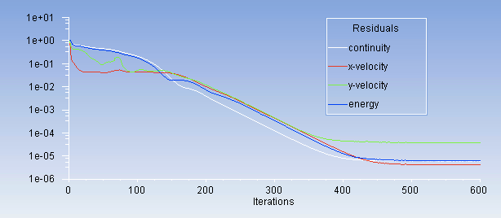

**Velocity Contour (Mach Number)**

Notice how the velocity is greater at the wall for the diverging section, this effect would be somewhat diminished if viscous effects were introduced.

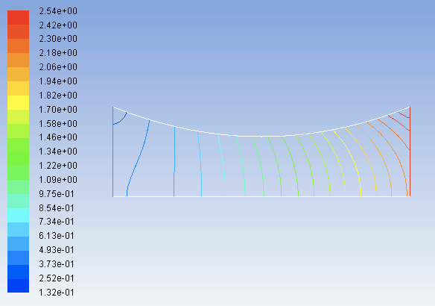

**Velocity X-Y Plot**

The velocity at the axis reaches Mach 2.05, while the velocity near the Wall reaches Mach 2.55

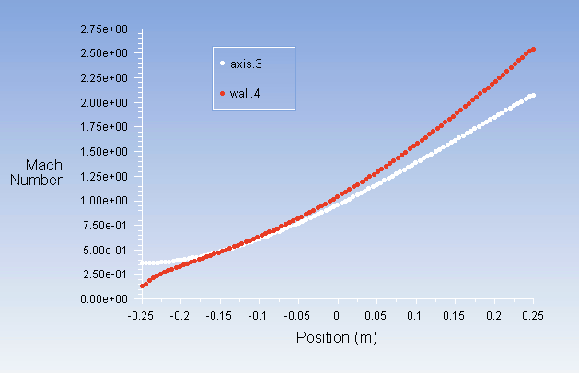

**Static Pressure (Pascals)**

Notice that the pressure decreases at the velocity increases from left to right.

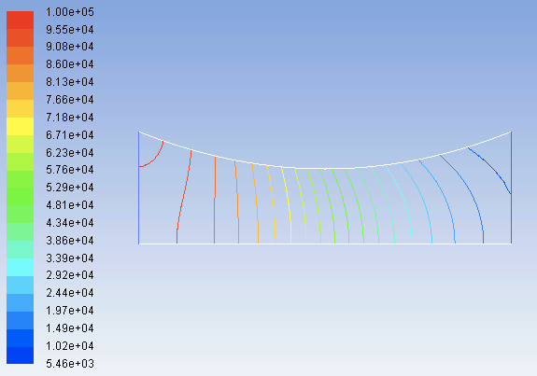

**Total Pressure**

Notice the pressure loss at the outlet due to false diffusion.

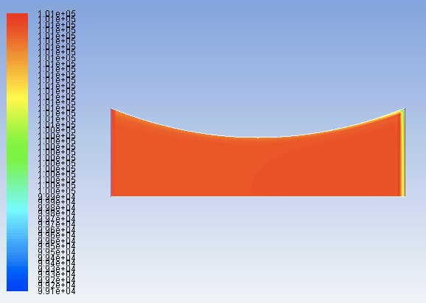

**Static Temperature (Kelvin)**

As the air accelerates the static temperature drops, since the energy must be conserved, the thermal energy is converted into kinetic.

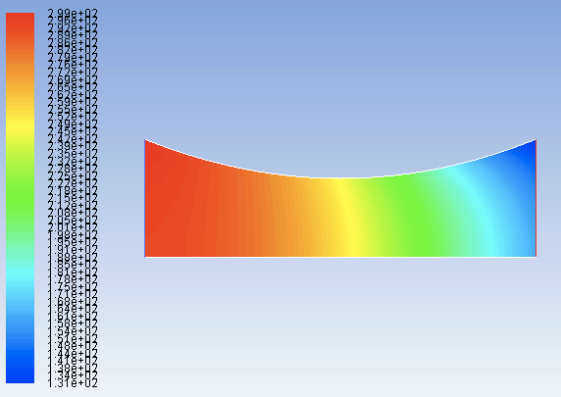

**Total Temperature (Kelvin)**

Notice the constant total Temperature of 300 Kelvin, and the round off error near the outlet.

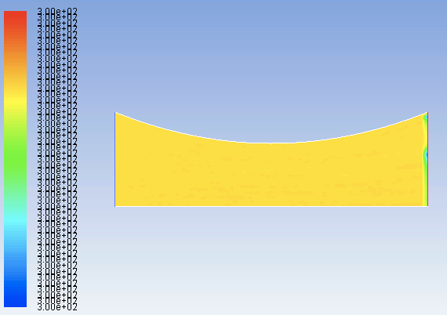

**Varying Outlet Radius to see effect on Velocity**

The simulation was run with outlet radii of: 0.15 m , 0.20 m , 0.25 m , 0.30 m , leaving all other parameters the same. The equation for points in the converging section is still y=0.8*x2+0.1, with the origin at the center of the bottom line. (Note: y is the radius of the nozzle, and the height of the wall in the axi-symmetric two-dimensional mesh)

For the right of the origin the equations for the nozzle wall are as follows:

0.15m: y= 0.8*x2 + 0.1

0.20m: y= 1.6*x2 + 0.1

0.25m: y= 2.4*x2 + 0.1

0.30m: y= 3.2*x2 + 0.1

**Sample of Large Outlet Mesh**

This is a mesh of the largest outlet radius used, Routlet = 0.30 m

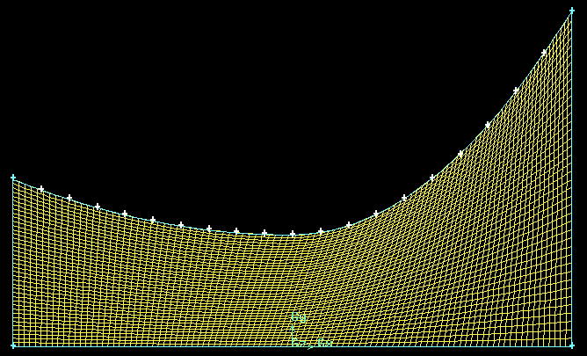

**Routlet vs Velocity of Axis and Near the Wall**

This is a comparison of maximum velocities at the axis and near the wall. The maximum velocity achieved near the wall increases linearly with the outlet radius, while the increase in maximum velocity of the cells at the axis diminishes as the outlet radius is increases.

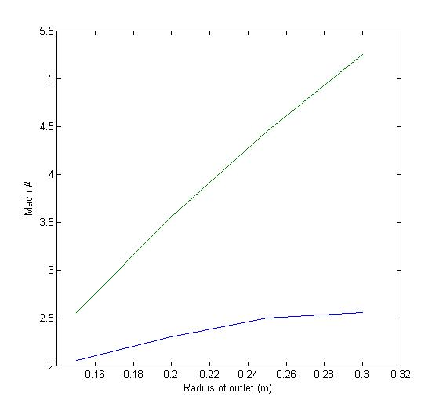

Axis

Near Wall

**Routlet vs Maximum Back Pressure for supersonic flow with no shocks inside nozzle**

The Second Order Upwind Scheme had difficultly converging at these higher back pressures, so the scheme was switched over to First Order Upwind to remove the instabilities. Notice how the Maximum Back Pressure decays exponentially compared to an increase in outlet radius. Only back pressures less than the values below, for a given radius, will produce supersonic speeds throughout the entire diverging section of the nozzle.

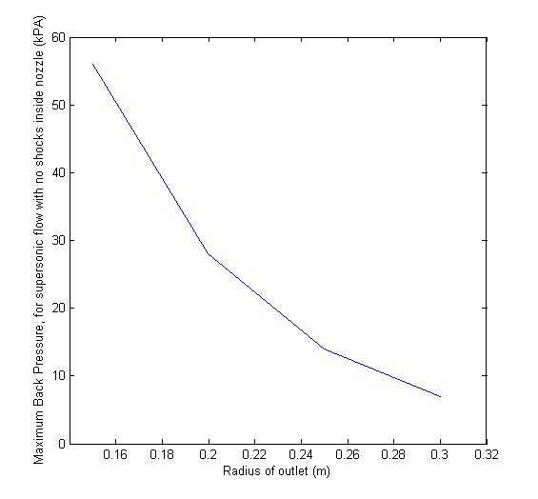

**Conclusions**

• For the given geometry, we see a linear relationship between Mach number & outlet radius near the wall, but the increase in axis Mach number diminishes as the outlet radius increases. This could be that there is a lag in the expansion effect of the nozzle accelerating the gas, would be interesting to see how adding viscous effects will affect the results, and how far the viscous region extends into the flow from the wall.

• For the study of the range of acceptable back pressures for the different outlet radiuses, an exponentially decaying relationship was found between outlet radius and the Maximum Back Pressure for supersonic flow with no shocks inside the nozzle. This is a helpful relationship to know for the development of rocket nozzles, if you know the acceptable range of back pressures the rocket engine will operate in.

• This research is a good foundation for further nozzle analysis. Future research could include trying different nozzle shapes to see if higher mach numbers for a given expansion ratio can be achieved, possibly convex, or a mix of concave (the current shape) and convex. Other research ideas include the adding of a combustion chamber before the inlet and use of a chemical mechanism to fully model an actual rocket engine, this was outside the scope of the current project.